# A….-ME-Syria-Tel Halaf- 6000 BCE-Terracotta- House Fertility Idol

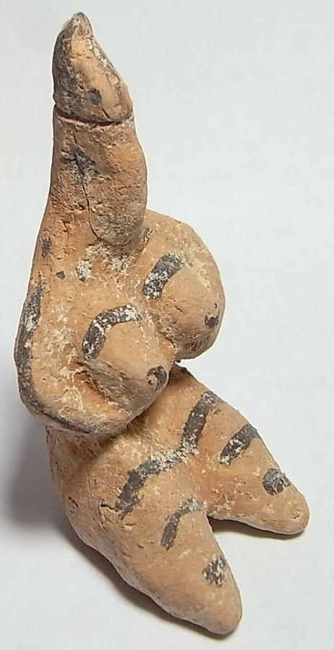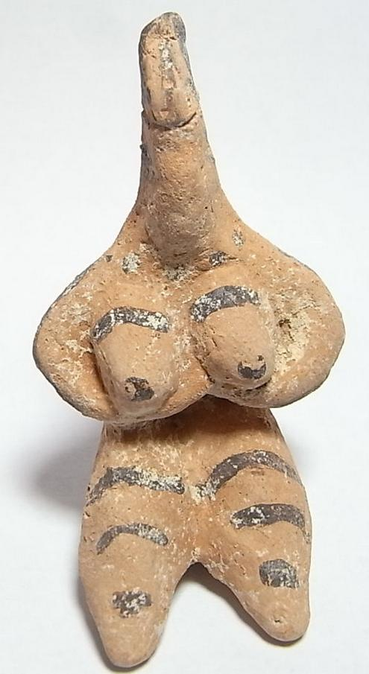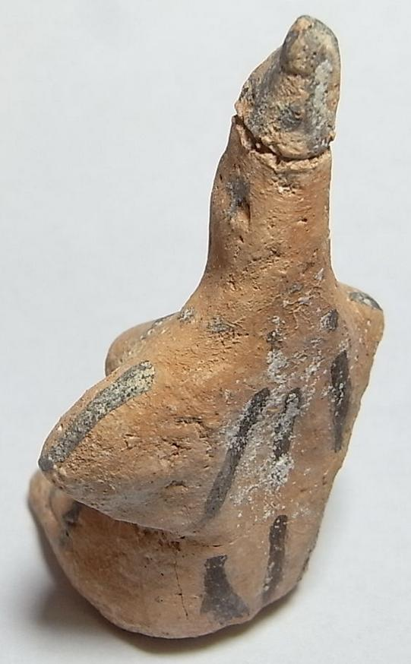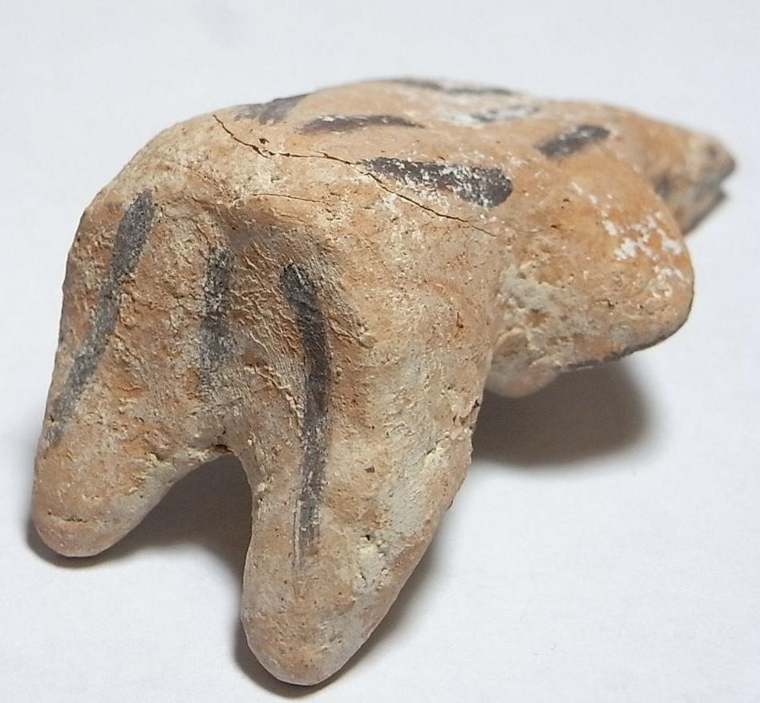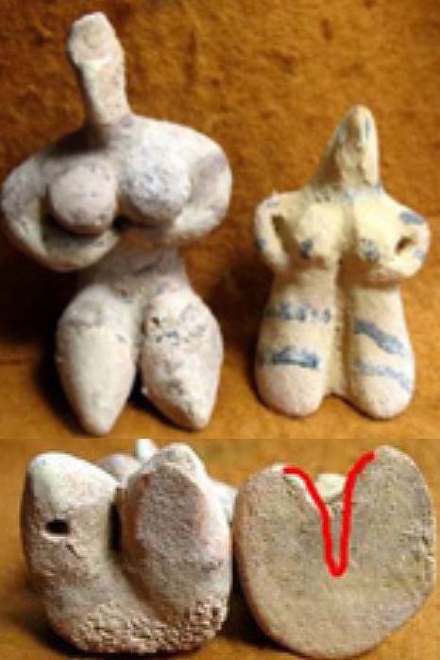

Figs. 1-4. reproduction of **Tel Halaf-Terracotta ­House Fertility Idol.**

**Figs 5-8. Comparison of genuine Tel Halaf figurine 4 and 6 showing separation of the legs from the underside. Figs. 5 and 7 showing reproduction of Tel Halaf figurine reproduction without separation of legs on the underside. From** [**http://www.waa.ox.ac.uk/XDB/images/world/tours/meso-forgeries-small.jpg**](http://www.waa.ox.ac.uk/XDB/images/world/tours/meso-forgeries-small.jpg)**.**

Case no.: 3

Accession Number:

Formal Label: **Tel Halaf figurine reproduction**

**Display Description:**

This example of a Tel Halaf figurine reproduction shows the underside with legs not separated (see Figs. 5 and 7, above). Tell Halaf culture (تل حلف‎‎) dates to 5000-4500 BCE, the first Neolithic site identified in NE Syria, which is characterized by glazed ceramics especially figurines painted with geometric designs and is identified with its type site of Tell Halaf. Examples found in northern Mesopotamia and in present-day Turkey, confirm trade and exchange mechanisms in the 6th millennium BCE.

**LC Classification:**

Date or Time Horizon:

Geographical Area:

**Map, GPS coordinates:** [36.8266°N 40.0396°E](https://tools.wmflabs.org/geohack/geohack.php?pagename=Tell_Halaf&params=36.8266_N_40.0396_E_type:landmark)

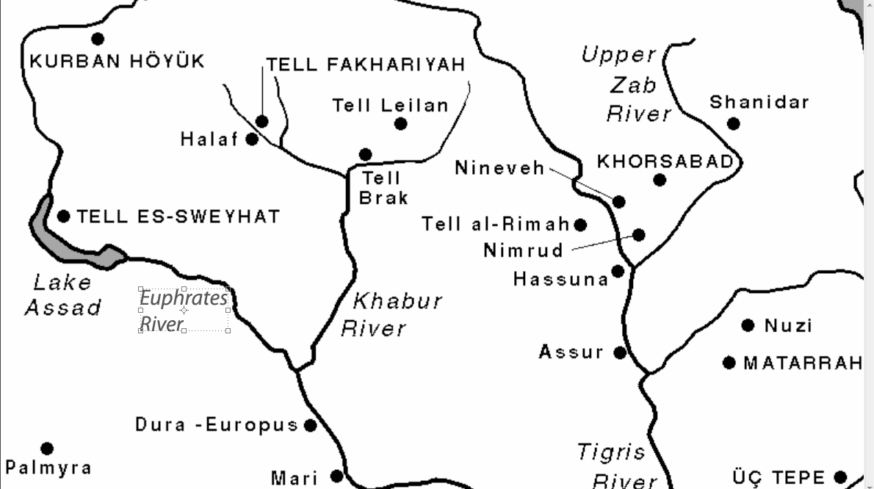

[http://oi.uchicago.edu/research/lab/map/maps/iraq.html](http://oi.uchicago.edu/research/lab/map/maps/iraq.html)

<http://www.tell-halaf-projekt.de/Bilder/Plan.htm>

Cultural Affiliation: Neolithic

Media: Terracotta-Charcoal paint

Dimensions: **H 75.45 mm**

Weight: **53.09 gm**

Condition: original, light firing cracks.

Provenance: Tell Halaf

**Discussion:**

The craze for Tel Halaf figurines began when excavations commenced ca. 1899 in the midst of a housing settlement and when figurines began to be unearthed. Reproductions of these figurines followed almost immediately. Today it is important to have a thermoluminescent study of each figurine from this area to establish its authenticity. See <http://www.collector-antiquities.com/184/>.

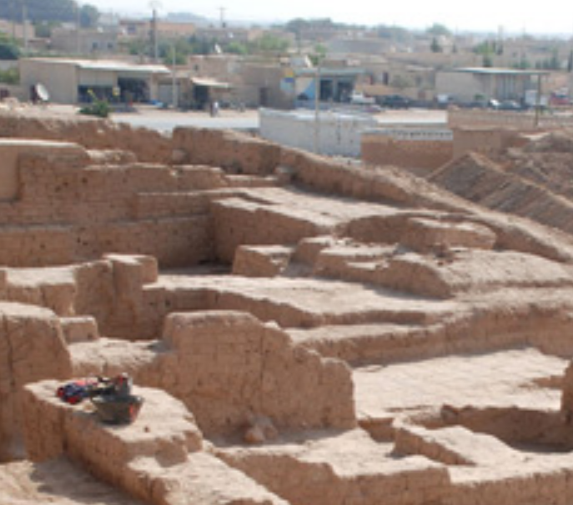

Tel Halaf Palace area where many figurines were excavated. <http://upload.wikimedia.org/wikipedia/commons/8/83/TellHalaf%2CNE-palace1.jpg>

**References:**

Sold by [meridian-coins-s...](http://myworld.ebay.com/meridian-coins-sussex-uk) ( [2033](http://feedback.ebay.com/ws/eBayISAPI.dll?ViewFeedback&userid=meridian-coins-sussex-uk) )

### Delivery package 1 of 1

Estimated delivery Monday, Jan 25, 2016 - Tuesday, Feb 2, 2016

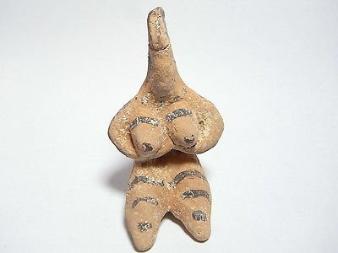

#### [Ancient Indus Valley Tel Halaf 6000 BC Terracotta House Fertility Idol. (A829B)](http://www.ebay.com/itm/172042644865)

|  |  |
| --- | --- |
| Item price | GBP 100.00 |
| Quantity | 1 |
| Item number | 172042644865 |
| Shipping service | Royal Mail International Signed |

## Shipping address

Ralph J Coffman Jr

149 Atlantic Ave

Swampscott MA 01907-2427

United States

## Order total

|  |  |
| --- | --- |
| Subtotal | GBP 100.00 |
| Shipping | GBP 7.20 |

**Total**

GBP 107.20

Order placed on

Sunday, Jan 17, 2016

Payment method

PayPal

Payment date

Sunday, Jan 17, 2016